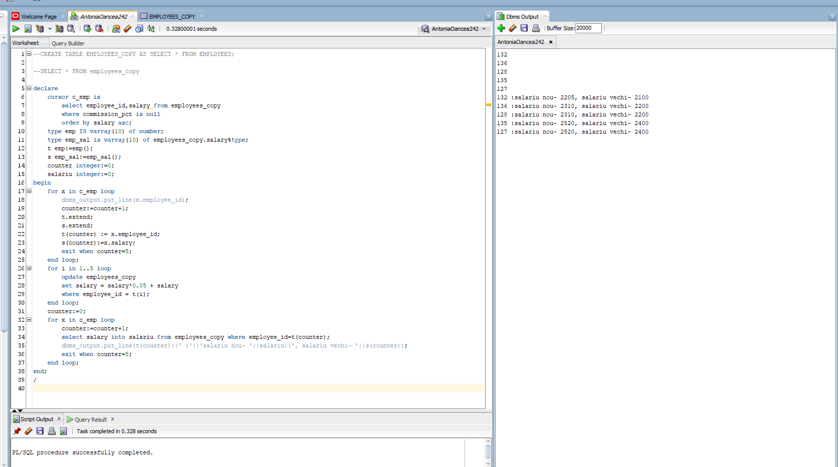

declare

cursor c_emp is

select employee_id,salary from employees_copy

where commission_pct is null

order by salary asc;

type emp IS varray(10) of number;

type emp_sal is varray(10) of employees_copy.salary%type;

t emp:=emp();

s emp_sal:=emp_sal();

counter integer:=0;

salariu integer:=0;

begin

for x in c_emp loop

dbms_output.put_line(x.employee_id);

counter:=counter+1;

t.extend;

s.extend;

t(counter) := x.employee_id;

s(counter):=x.salary;

exit when counter=5;

end loop;

for i in 1..5 loop

update employees_copy

set salary = salary*0.05 + salary

where employee_id = t(i);

end loop;

counter:=0;

for x in c_emp loop

counter:=counter+1;

select salary into salariu from employees_copy where employee_id=t(counter);

dbms_output.put_line(t(counter)||' :'||'salariu nou- '||salariu||', salariu vechi- '||s(counter));

exit when counter=5;

end loop;

end;

/